# Starting Eclipse IDE

On starting Eclipse for the first time, the following pop-up window will appear.

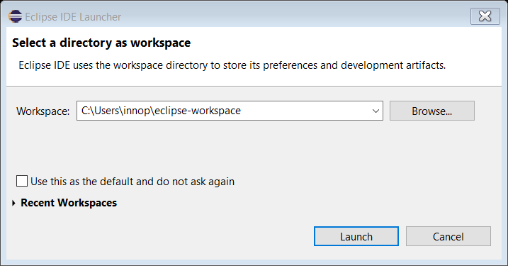

Figure 14: Workspace directory

Select a workspace directory and click on Launch.

It is recommended to create a unique workspace that will be used exclusively for the projects related to the GCC toolchain. The workspace selected should not have a path name that is excessively long, and it is best to avoid spaces in the path name.